Norfolk County Council proposes to make a Temporary Traffic Regulation Order (the “Order”) (STRO13903) affecting the C645/2 Round House Way from its junction with A11/120 Newmarket Road Roundabout to its junction with C645/62 Round House Way (“Road A”) and; C645/62 Round House Way from its junction with C645/2 Round House Way to its junction with C645/50 Round House Way Roundabout (“Road B”) and; C645/50 Round House Way Roundabout (“Road C”) and; C645/68 Round House Way from its junction with A11/120 Newmarket Road Roundabout to its junction with C645/62 Round House Way (“Road D”) in the Parish of Cringleford to facilitate resurfacing works, the Roads A–D will be temporarily closed/restricted (except for pedestrian access) for the duration of the works/period the closure is necessary which is anticipated to be between 20:00 and 06:00 from 12th to 16th January 2026, but may continue to be closed/restricted until the 27th February 2026 where the closure/restriction is still required beyond the anticipated dates.

NB: Please note that the works are anticipated to take place between 20:00 and 06:00 each night from 12th to 16th January 2026.

Alternative route is via: Round House Way, Colney Lane, Watton Road, Earlham Road, Colman Road, Mile End Road, Newmarket Road (Colney, Cringleford).

The works promoter for this restriction/closure is: Breheny Civil Engineering Ltd.

Vehicular access will be permitted to a final destination in the Roads A–D where signs indicating such access is possible and permitted are in place.

The Order shall automatically revoke on the completion of the works/when the closure is no longer necessary or otherwise on the 27th February 2026 without further notice.

If necessary, the restriction could run for a maximum period of 18 months from the date the Order is effective.

A person who contravenes, or who uses or permits the use of a vehicle in contravention of the restriction/closure imposed by the Order shall be guilty of an offence.

Penalty: £1000 maximum fine on conviction and/or endorsement for contravention.

In the event of the start date being delayed the new start date will be displayed on site in advance.

Full details on the closure are available at https://one.network. Any enquiries that cannot be answered on the one.network website should be directed to the South Area Streetworks (Infrastructure Department) contactable by telephone at 0344 800 8020 or email at streetworks@norfolk.gov.uk

Dated this 2nd day of January 2026.

Katrina Hulatt
Director of Legal Services (nplaw)
County Hall
Martineau Lane
Norwich
NR1 2DH

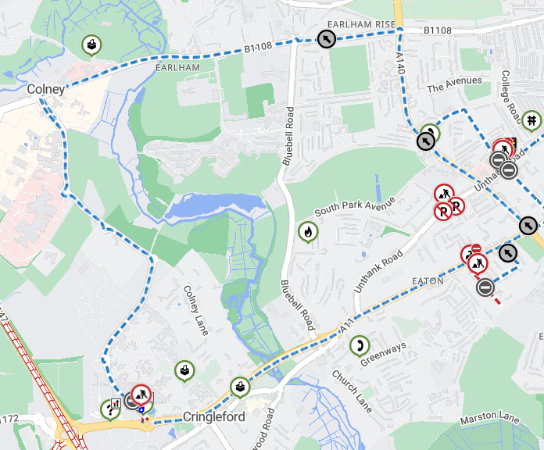

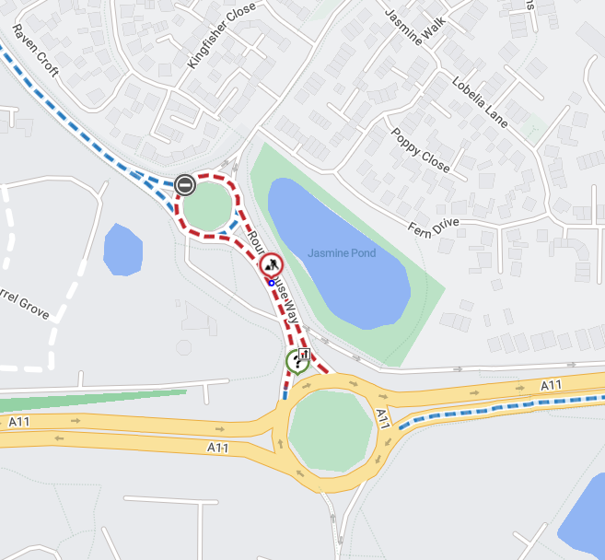

Imagery © 2025 MapTiler | Imagery © 2025 Hexagon | © MapTiler © OpenStreetMap contributors

